MGTA 611 Term Project Proposal

Optimizing Holiday Inventory & Markdown Strategy via Multivariate Demand Forecasting

Amy Zhou (255809550)
Hosanna Udoh (200870740)
Mohammad Al-Maghaireh (255801000)
Suhail Ahmed (255809540)
MMA, Wilfrid Laurier University
MGTA 611: Business Application of Artificial Intelligence
Professor Michael Blair
February 2nd 2026
Word Count: 1769

1. Executive Summary
In retail, the Golden Quarter refers to a period between October and December when the largest surge of demand for the year is experienced. Concentrated demand during this period often dictated retailer profitability. The business problem that has been identified for this project is the miscalculation of inventory levels which affects a retailer’s ability to meet demand without incurring substantial loss - in this project the retailer of focus in Walmart. It has been recognized that various factors influence demand and logistical constraints. To address these factors we intend to combine our retail dataset with economic indicator data and operational factor data to capture the logistical impact of fuel prices and temperature/weather on supply. The goal of this project is to deliver a model that can minimize errors in supply using error-weighting and non-linear modeling to aid increased predictability in the Golden Quarter inventory.

2. Business Context & Problem Statement
Across retailers world-wide, the holiday season is found to be one of the volatile yet influential periods in the purchasing calendar. The national retail federation found that holiday sales from the months of November and December account for approximately 20% of total retail sales. (National Retail Federation) Miscalculations in inventory can cause a disproportionately high cost, monetary and otherwise. A blog post by ToolsGroup, a supply chain consulting company mentions how “Each missed sale increases the risk of long-term customer churn, reputational harm, and costly operational workarounds.” (Iorio, 2025)
Furthermore, Mirakl, a technology partner focused on helping companies drive digital growth cites that inventory distortion due to out-of-stocks is projected to be approximately $1.2 trillion globally and general inventory distortion raising this projected cost to $1.7 trillion. (Trifilio & Mirakl, 2025) (IHL Group) In addition, due to markdowns from inventory overstocking, McKinsey & Company researchers found that 59% of companies worldwide that had invested in consumer package goods promotions lost money. (Hwang et al., 2019) This discredits the presumed solution - end of season sales - to overstocking errors.
To address the business problem of overstocking and understocking - that result in a loss of consumer trust, monetary loss and brand reputation damage - a robust model will be developed that would allow for retailers to align their inventory levels with predicted demand and logistic limitations to ensure optimized supply is aligned with holiday demand shifts that account for a substantial proportion of total retail sales.

3. Data Acquisition & Description
The project utilizes the Walmart Recruiting - Store Sales Forecasting dataset. To make this data usable a sophisticated preprocessing pipeline is required.
- Primary Sales Data (train.csv): Contains Weekly_Sales across 45 stores and 99 departments. The target variable will be normalized to facilitate faster convergence during backpropagation.
- Exogenous Features (features.csv): * Economic Indicators: CPI and Unemployment rates will be used to model regional purchasing power.
- Operational Factors: Fuel Price and Temperature serve as proxies for logistics costs and foot traffic.
The Markdown Challenge: MarkDown1-5 features are sparse (pre-2011). Instead of simple imputation, we will utilize Binary Masking flags to allow the model to distinguish between a "Zero Markdown" and "Missing Data."

4. Preliminary Analysis (EDA & Requirements)

4.1 Exploratory Data Analysis (EDA)
An initial audit of the merged dataset reveals several critical patterns that will dictate the neural network's architecture. Most notably, the "Holiday Multiplier" is evident in graph 1; average weekly sales during holiday periods are approximately $1,100 higher per department than non-holiday weeks. However, aggregate averages mask extreme volatility in specific sectors. For instance, Department 72 (likely Electronics or Toys) and Department 92 show standard deviations exceeding $44,000, driven almost entirely by explosive peaks during the Thanksgiving and Christmas windows. This confirms that a "one-size-fits-all" forecasting approach will fail; the model must learn store-department specific seasonality.

The Markdown 1-5 features present a significant technical hurdle. Approximately 50% to 65% of the entries for MarkDown1 through MarkDown5 are missing. Detailed inspection shows these values are not missing at random but are absent for the first 20 months of the dataset as shown in graph 3. This "data sparsity" implies that the model must be trained to handle cold-start scenarios, where it relies on economic proxies like CPI and Unemployment before promotional data becomes available. Interestingly, graph 4 shows us that linear correlation coefficients between sales and economic indicators like Fuel Price (-0.0001) and CPI (-0.02) are nearly zero . This lack of linear relationship strongly justifies the use of a secondary Deep Learning Model, as the network can identify non-linear interactions, such as how a spike in fuel prices might disproportionately lower spending in smaller "Type B" stores compared to larger "Type A" hubs as shown in graph 2.

4.2 Requirements Analysis
- Functional Requirements:
- Holiday-Weighted Optimization: The system shall calculate the Weighted Mean Absolute Error (WMAE) as the primary objective function. The model must apply a $5\times$ penalty weight to predictions occurring during the weeks of the Super Bowl, Labor Day, Thanksgiving, and Christmas..
- Returns Processing Logic: The preprocessing pipeline must programmatically handle negative sales values (returns). The system must support a configurable toggle to either:
    - Clip negative values at zero.
    - Transform them into a distinct "return-rate" feature vector.
- Categorical Feature Embedding: The model must utilize Entity Embeddings for high-cardinality categorical variables (45 Stores, 99 Departments). This replaces one-hot encoding to map these entities into a lower-dimensional continuous space.
- Non-Functional Requirements:
- Data Normalization (Scalability/Stability): To ensure gradient stability and prevent features with high magnitudes (e.g., CPI > 200, Markdowns > 1,000) from dominating the model, all continuous inputs must undergo Feature Scaling. The system shall support either Z-score normalization or Min-Max scaling.
- Mathematical Precision: The model's loss function must remain differentiable and strictly adhere to the $WMAE$ weighting criteria to ensure convergence aligns with business-critical dates.
- Dimensionality Management (Efficiency): The architecture must minimize feature bloat. By implementing Entity Embeddings, the system must reduce the dimensionality of the input space compared to a naive approach, while preserving latent relationships between similar stores and departments.

5. Proposed Solution & Methodology

5.1 System Architecture & Component Design
The proposed solution follows a modular pipeline architecture composed of interacting components, each responsible for a distinct stage of the forecasting workflow. This design enables independent development, testing, and optimization of system modules while maintaining scalability and maintainability.
Component | Responsibility | Data Interface
Data Ingestion & Preprocessing | Merging sales, metadata, and economic indicators; binary masking for missing values | Output: Standardized Tabular Dataset
Feature Engineering | Generating temporal indicators, holiday proximity, and lagged demand variables | Output: Structured Modeling Feature Matrix
Prediction Engines | Training XGBoost with holiday-weighted loss and LSTM for sequential dependencies | Input: Feature matrix  Output: Weekly department-level sales forecasts
Evaluation | Computing WMAE metrics and SHAP-based feature importance | Input: Forecasts/Actuals Output: Performance reports and business insights

5.2 Component Deep-Dive: Feature Engineering Logic
Temporal features such as week of year, month, and holiday proximity indicators (e.g., days to Christmas and pre-holiday ramp windows) will explicitly model calendar-driven demand spikes that distort standard seasonal patterns (Fildes et al., 2022). Lagged sales features at the store-department level (four-week and 52-week lags) will capture short-term trends and recurring holiday effects. In addition, economic indicators (CPI, unemployment rate, fuel price), store attributes (type, size), and markdown variables will be incorporated to model purchasing power variation, operational scale differences, and promotion-driven demand responses. Aggregated promotional indicators will improve robustness under sparse markdown conditions.

5.3 Component Deep-Dive: Modeling & Evaluation Strategy
The primary forecasting model will use XGBoost, which performs well in retail forecasting by capturing nonlinear relationships and interaction effects between promotions, store characteristics, and macroeconomic conditions (Zhang & Wu, 2025). Training will apply holiday-weighted loss, assigning a five-fold penalty to forecast errors during Super Bowl, Labor Day, Thanksgiving, and Christmas weeks.
To complement the ensemble approach, an LSTM neural network will be implemented to model sequential dependencies and long-term temporal sales patterns. Model performance will be benchmarked against a time-series baseline using Prophet, which models trend, seasonality, and holiday effects without external predictors (Taylor & Letham, 2018). Evaluation will focus on WMAE performance both overall and during holiday periods.
Finally, feature importance and SHAP-based analysis will be used to evaluate markdown effectiveness by identifying which promotion types drive sales uplift and whether promotions generate incremental demand or primarily shift purchase timing, supporting data-driven inventory and promotion planning decisions.

6. Feasibility & Timeline
The project is highly feasible within the academic term, as the Walmart dataset is a well-documented benchmark in the machine learning community. By utilizing a "Champion-Challenger" architecture—where a tree-based ensemble (XGBoost) is benchmarked against a Deep Learning model (LSTM)—we ensure a robust solution even if one architecture struggles with the data’s sparsity.

6.1 Tools & Infrastructure
We will utilize Python 3.10+ with Pandas and NumPy for high-speed data manipulation. The modeling phase will leverage XGBoost for the baseline and PyTorch or TensorFlow for the Deep Learning components, specifically focusing on Entity Embedding layers to handle the high cardinality of 45 stores and 99 departments (Guo & Berkhahn, 2016).

6.2 Risk Management & Mitigation
- The Markdown Data Gap: As noted in Section 4.1, Markdown data is missing for the first 20 months. To mitigate this, we will implement Binary Masking flags. This allows the neural network to learn a "missingness" pattern rather than treating nulls as zero-value promotions, preventing the model from being misled by the data gap.
- Feature Volatility: High standard deviations in specific departments (e.g., Electronics) risk model divergence. We will apply Z-score normalization to the target variable and features to ensure stable gradient descent during the training of the LSTM.

6.3 Project Timeline
Week | Focus Area | Key Deliverables
Week 1 | Data Engineering | Pipeline for Z-score scaling, Binary Masking, and merging Economic/Sales data.
Week 3 | Architectural Design | Implementation of Entity Embeddings for Categorical Variables and Lag-feature generation.
Week 5 | Model Optimization | Training XGBoost and LSTM; Hyperparameter tuning using the 5x WMAE holiday penalty.
Week 7 | Analysis & Reporting | SHAP-based feature importance analysis (Zhang & Wu, 2025) and final synthesis.

7. Conclusion
Overall, this project moves retail forecasting from reactive historical averaging to proactive, multivariate intelligence. By integrating regional economic indicators and promotional markdowns into a Deep Learning framework, we address the $1.7 trillion "inventory distortion" problem identified by the IHL Group.
While holiday weeks represent only a fraction of the calendar, their 20% contribution to annual revenue (National Retail Federation) makes them the ultimate test of a retailer's supply chain. Our model provides a strategic safeguard against the "margin-killing" effects of overstocking and the reputational damage of stockouts (Iorio, 2025). Ultimately, this project demonstrates how sophisticated error-weighting and non-linear modeling can turn volatile holiday demand into a predictable driver of year-end profitability.

References
Fildes, R., Ma, S., & Kolassa, S. (2022). Retail forecasting: Research and practice. International Journal of Forecasting, 38(4), 1283–1318. ScienceDirect. 10.1016/j.ijforecast.2019.06.004
Guo, C., & Berkhahn, F. (2016). Entity Embeddings of Categorical Variables. arXiv preprint arXiv:1604.06737. https://arxiv.org/abs/1604.06737
Hwang, M., Murphy, R., Shaikh, A. W., & McKinsey & Company. (2019, October 23). How analytics can drive growth in consumer-packaged-goods trade promotions. McKinsey & Company. Retrieved January 31, 2026, from https://www.mckinsey.com/capabilities/growth-marketing-and-sales/our-insights/how-analytics-can-drive-growth-in-consumer-packaged-goods-trade-promotions#/
IHL Group. (n.d.). Fixing Inventory Distortion – Are We There Yet? IHL Group. Retrieved January 31, 2026, from https://www.ihlservices.com/product/fixing-inventory-distortion-are-we-there-yet/
Iorio, A. (2025, December 18). Cost of Stockouts vs Overstock: Impact on Profitability. ToolsGroup. Retrieved January 31, 2026, from https://www.toolsgroup.com/blog/cost-of-stockouts-vs-overstock/
National Retail Federation. (n.d.). Winter Holiday FAQs. National Retail Federation. Retrieved January 31, 2026, from https://nrf.com/research-insights/holiday-data-and-trends/winter-holidays/winter-holiday-faqs
Taylor, S. J., & Letham, B. (2018). Forecasting at scale. The American Statistician, 72(1), 37–45. Taylor & Francis Online. 10.1080/00031305.2017.1380080
Trifilio, S., & Mirakl. (2025, September 22). Out-of-stocks: The $1.2T eCommerce inventory management problem crushing retailers. Mirakl. Retrieved January 31, 2026, from https://www.mirakl.com/blog/out-of-stocks-ecommerce-inventory-management-problem
Zhang, M., & Wu, L. (2025). Sales forecasting and data-driven marketing strategies for e-commerce platforms using XGBoost. International Journal of Intelligent Information Technologies, 21(1), 1–21. IGI Global. 10.4018/IJIIT.382563

Appendix
Graph 1

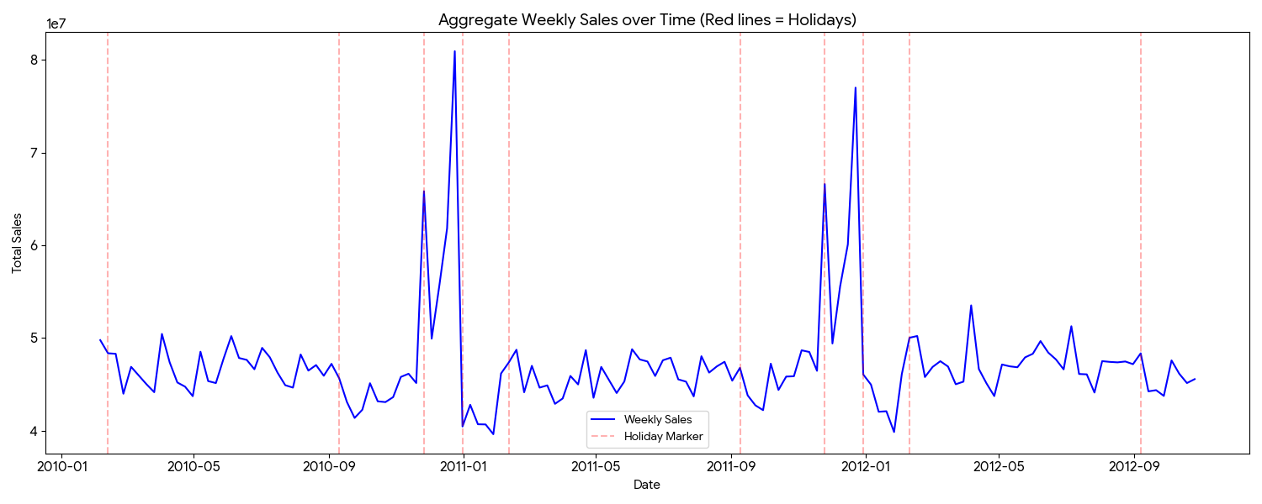

Graph 2
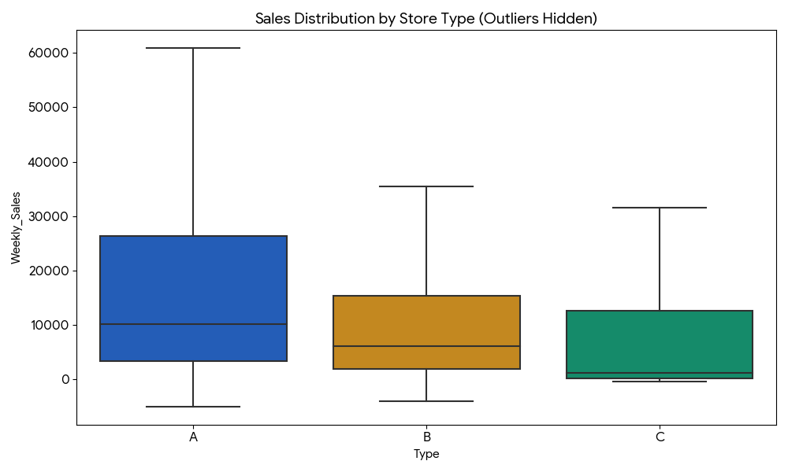

Graph 3
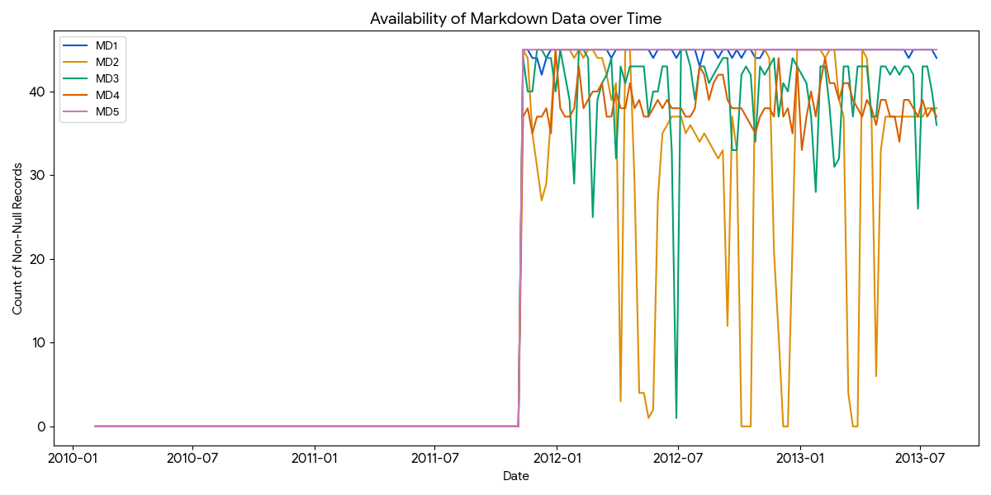

Graph 4
